**PROJECT REPORT**

**VOYAGE VISTA: ILLUMINATING INSIGHT FROM UBER EXPEDITIONARY ANALYSIS**

**TEAM MEMBERS:**

1**.** MUTHULAKSHMI

2. NANCY MIRACULINE

3. NIVETHA

4. PRAKASHRAJ

**MENTOR:**

C. RAMACHANDRAN

This Project was all about how to use Tableau software, which involved the following steps:

* Empathy Map
* Brainstorming Map
* Collection and Connection of data set
* Preparation of visualization Sheets
* Dashboard
* Story
* Publishing in Tableau

**INTRODUCTION:**

Uber is a multinational transportation network company that operates a ride-hailing platform. It was founded in 2009 by Garrett Camp and Travis Kalanick and is based in San Francisco, California. Uber Provides a convenient way for individuals to request rides from drivers who use their personal vehicles.

Uber Drivers Analysis refers to the Analysing the number of Trips taken by Uber drivers can provide insights into their overall activity and the demand for rides specific areas.

Daily, Weekly or Monthly Analysis: Uber’s Data can be analysed on daily, weekly, monthly basis to understand the trends and patterns of trips of volumes. The major of our project is to use Data Analysing techniques to find unknown patterns in Uber Drives Data set. The Research is carried out on Uber drives data collected from the year 2016.

**Empathy Map:**

Our team started our project with the creation of Empathy Map. firstly We collected the points about voyage vista: Illuminating Insights from Uber Expeditionary Analysis: We grouped the points under says, thinks, does and feels.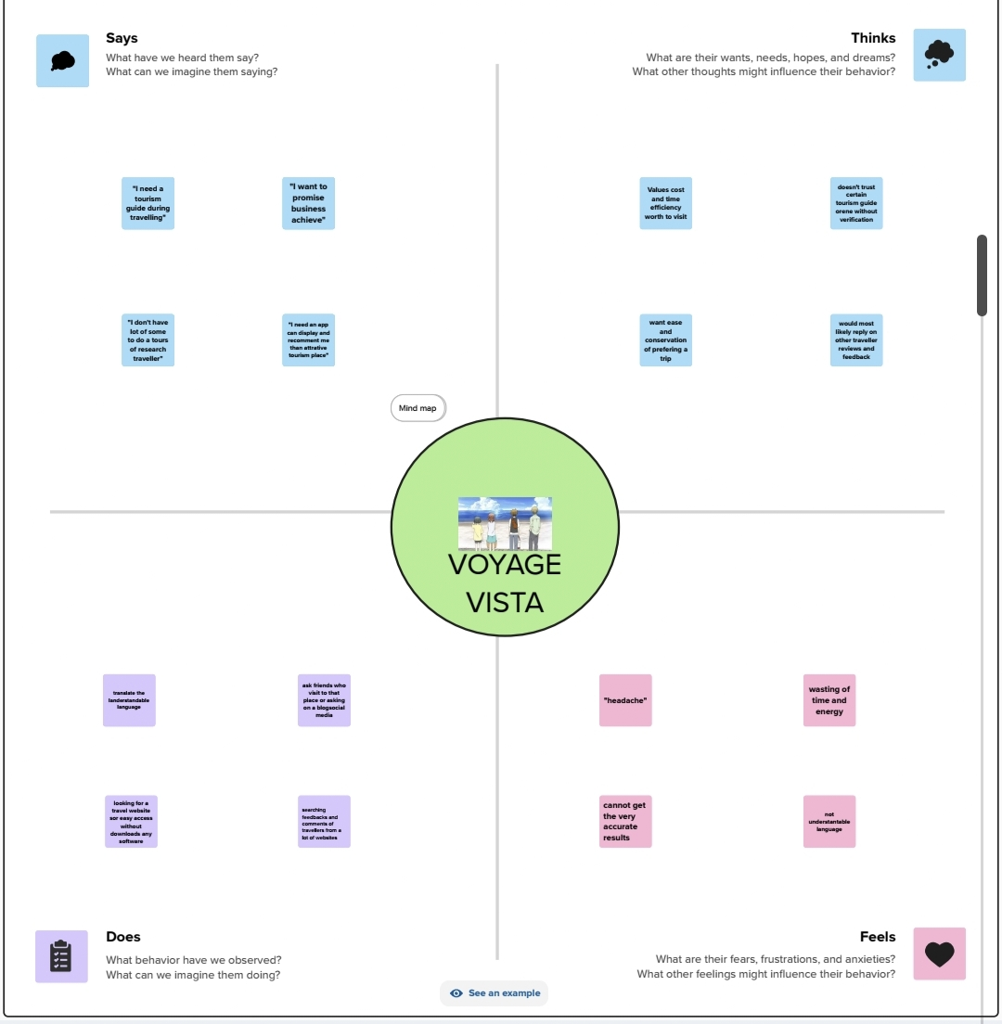

**Brainstorming Map:**

In the brainstorming map, each contributed 3 points regarding the Voyage Vista: Illuminating Insight from Uber Expeditionary Analysis and grouped in Brainstorming map.

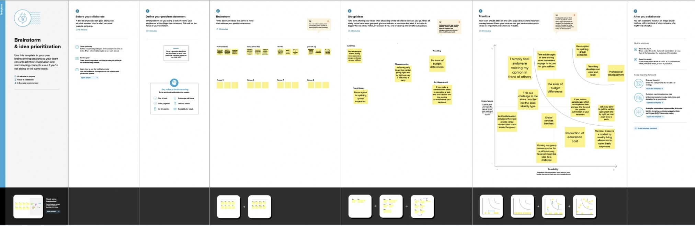

**Dashboard: 1 & 2**

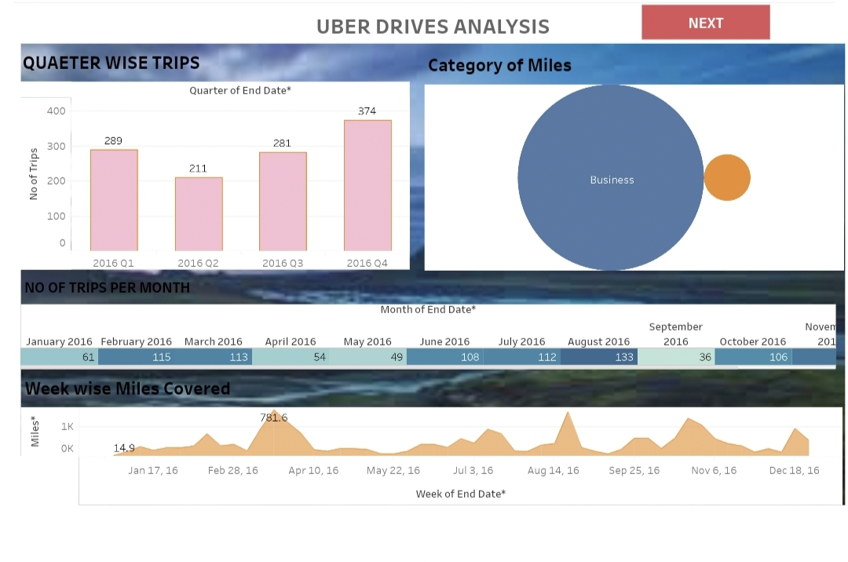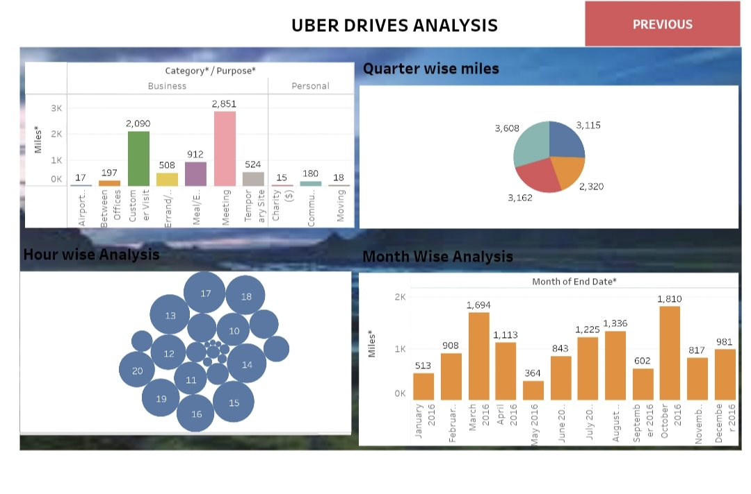

**Story: 1**

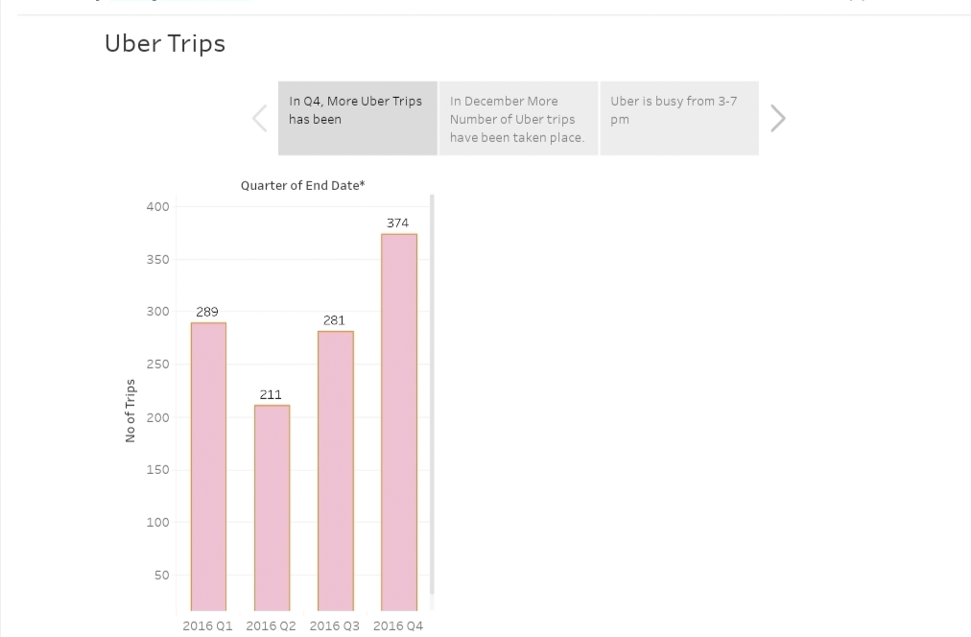

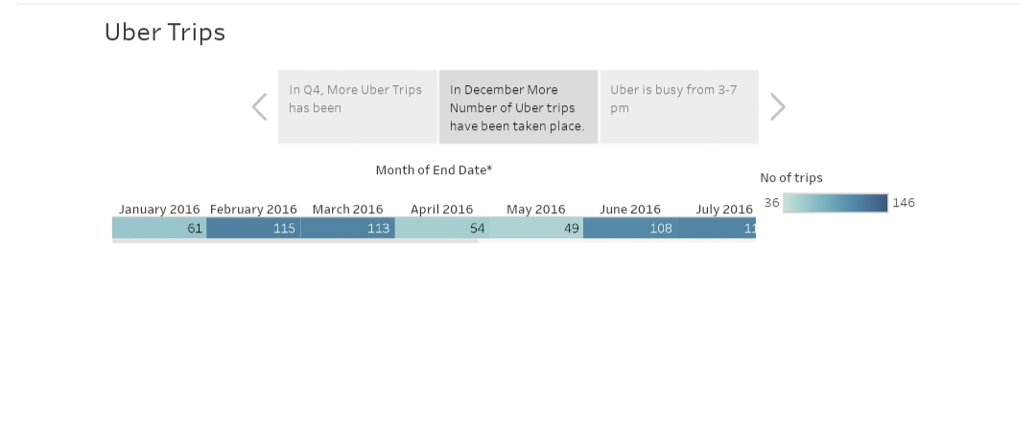

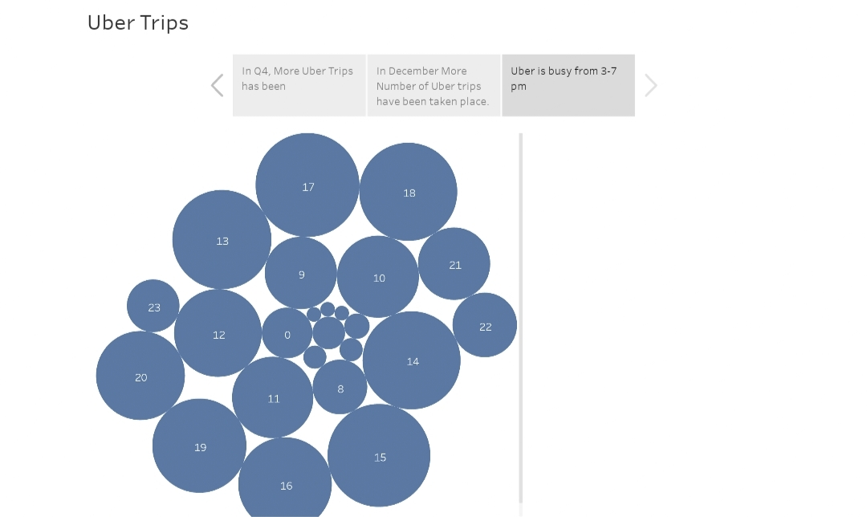

**Story: 2**

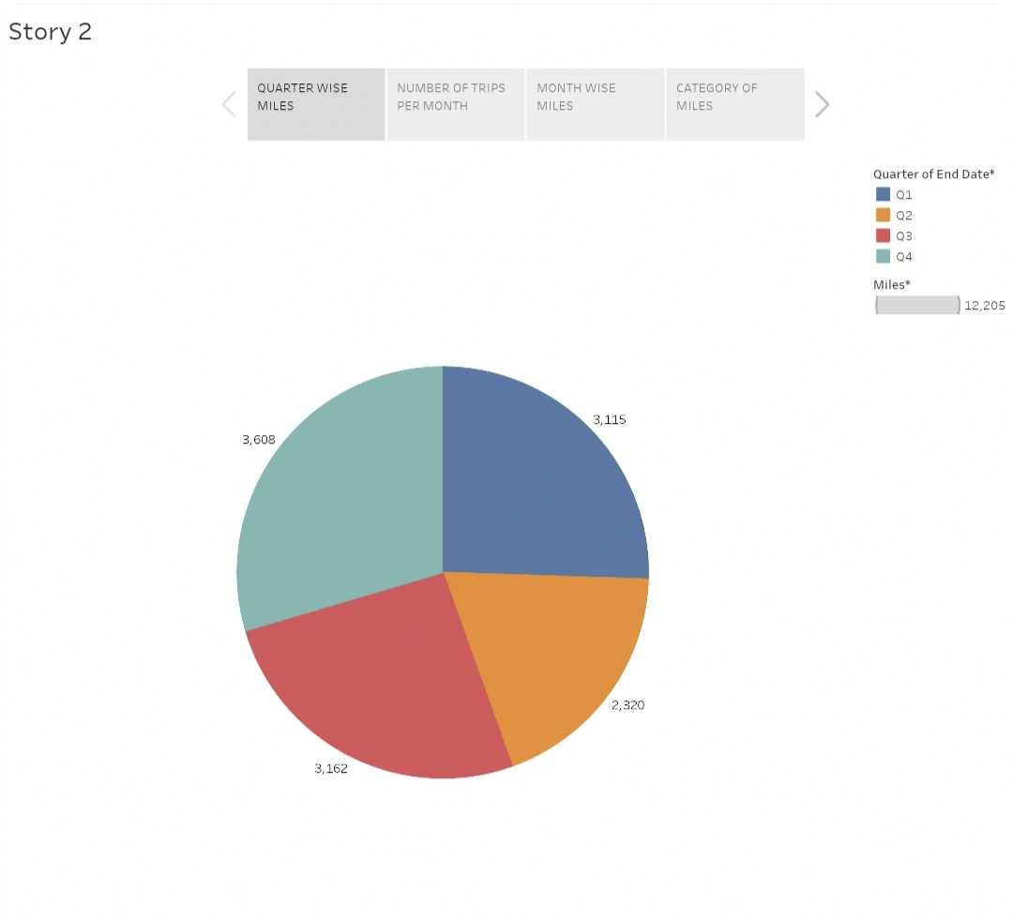

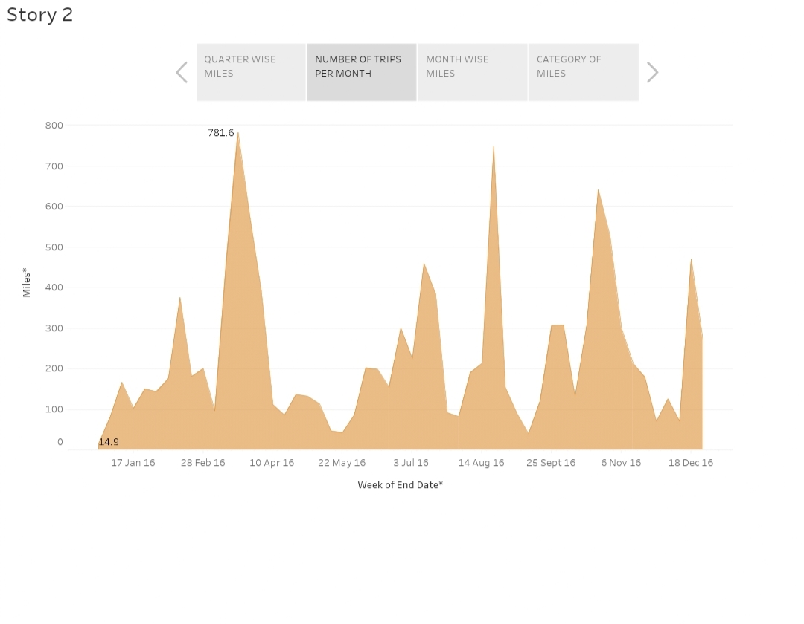

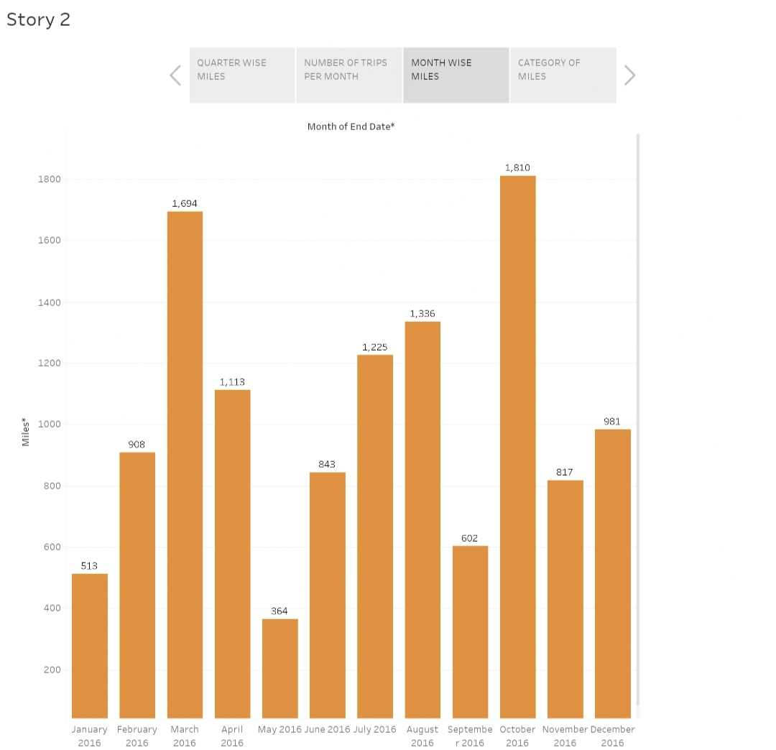

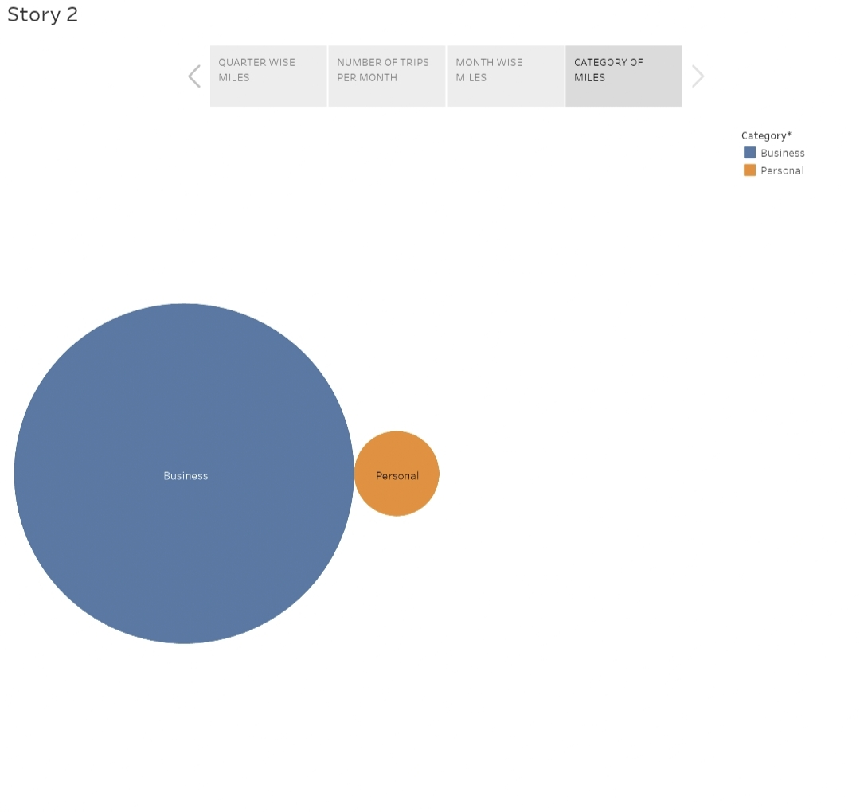

**ADVANTAGES & DISADVANTAGE:**

**ADVANTAGES:**

**Data-Driven Decision Making:**

Expeditionary analysis provides Uber with a data-driven approach to

Make critical decisions. It allows them to leverage large datasets to gain insights

Into their operations and customer behavior.

**Real-Time insights:**

Uber can access real-time data, enabling them to respond quickly to

Changing market conditions, optimize routes, and improve customer experiences.

**Efficiency Improvements:**

By analyzing data, Uber can identify inefficiencies and bottlenecks

In their operations, leading to cost reductions and improve service quality.

**Enhanced Safety:**

Expeditionary analysis can help uber identify safety-related issues,

Such as driver behavior, accident hotspots, and implement measures to improve

Safety for both drivers and passengers.

**Personalized Services:**

Uber can use data analysis to personalize services for users, offering

Customized recommendations and promotions.

**DISADVANTAGES:**

**Data Privacy Concerns:**

Uber’s access to vast amounts of customer data raises concerns about data privacy and the potential for misuse of sensitive information.

**Reliance on technology:**

An overreliance on data analysis can lead to a loss of the human touch

And understanding in customer service, which may impact user satisfaction.

**Data Security Risks:**

Storing and processing large volumes of data exposes Uber to security

Risks, such as data breaches and cyberattacks.

**Bias in algorithms:**

Data analysis can reinforce biases present in the data, potentially leading

To discrimination or unfair practices.

**Data Quality:**

The quality of data is crucial for accurate analysis. Inaccurate or

Incomplete data can lead to incorrect conclusions and decisions.

**APPLICATIONS:**

Route Optimization: Uber uses expeditionary analysis to continuously

Optimize driver routes in real-time.

Dynamic Pricing: Uber employs data analysis to implement surge pricing during peak hours or high-demand situations.

Driver Behavior Improvement: Expeditionary analysis can be used to monitor and improve driver behavior.

Customer Experience Enhancement: Uber uses data to personalize

The user experience.

Safety Enhancement: Uber leverages data to enhance safety measures.

**COLLECTION AND CONNECTION OF DATA SET:**

Regarding our project Title, A dataset is been collection from

The Naan Mudhalvan platform and connected the dataset to the

Tableau.

**PREPARATION OF VISUALIZATION SHEETS:**

We ourselves created 5 questions on consumer’s point of view

And tried to answer these questions through visualization sheets using Bar graphs,

Donut chart and histogram.

**DASHBOARD:**

We created dashboard placing all the visualization sheets in the

Double dashboard.

**STORY:**

After the completion our dashboard we have created a story section in which we extracted the observation from visualization sheets.

**PUBLISHING IN TABLEAU:**

We have published our dashboard and story in our team

Leader’s tableau public ID.

**CONCLUSION**:

From this project we learned to analysis a dataset and the usage of

Tableau Software.